


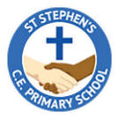
Year 3 Curriculum Overview
Spring 1

English –
Our ‘book for hook’ for this half term is ‘Jim and the Beanstalk’. We will use the structure of the story to write our own stories based on tales with a twist. Following this, we will write diaries to reflect on Jack’s experiences in the story.

Maths-
We will begin the half term recapping multiplication of 2-digit numbers and then learning methods for 2-digit division. Following this we will be learning how to calculate length and perimeter.
Jim and the Beanstalk
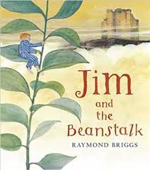

PE:
PE will be taught on Tuesday and Friday. Please make sure children come to school in their PE kits on these days as per our PE policy.
History-
Our enquiry question is ‘How did metal change the way we live?’. We will be learning about the Iron Age and the developments and lifestyles during this period.

RE-
Our ‘big question’ this half term is ‘What kind of world did Jesus want?’. We will explore stories and parables from the Bible and reflect on how these impact the lives of Christians today.

PSHCE-
We will be exploring dreams and goals. We will navigate and share our ambitions and think of positive ways we can face our challenges.
Science-

This half term we will be learning about magnets and forces. We will explore push and pull forces, learn how magnets work and carry out some investigations relating to magnetic materials.

French-
We will be learning vocabulary based around French foods and learning how to order items in a restaurant or café.
Art-
We will be developing our painting skills, leaning how to use a range of media to create prehistoric art.
Music-
Year 3 will be taught music by a specialist music teacher this half term, leaning how to play ukuleles.

