
St Stephen's C.E. Primary School
Audenshaw Road, Audenshaw,
Manchester,
England,
M34 5HD
admin@st-stephens.tameside.sch.uk
Dear Parents/Carers,
We would like to welcome back all of our Year 4 parents and children to the start of a new calendar year. We hope that you and your family has had a relaxing Christmas break and is as excited as we are to start 2026 in a positive way.
As always, we would like to say thank you for all the support you have given your child last term. A strong partnership with you will make a great difference in your child’s education.
Expectations:
We are working hard to remember to follow our School Rules, Ready, Respect & Safe. Children will be expected to focus on their learning behaviour so we are ready for our learning.
Homework – Each week, children are expected to practise their times tables and spellings. These will be based on the work we do in school. Times-tables will be tested during daily Maths lessons and spellings on Fridays.
Reading and reading records- It is a school-wide expectation that children should read daily and that this is recorded in reading records (by the child or an adult). It is important that children bring in their records and take them home every day. When reading, please mark down the date, book title and the pages read. Record books will be checked once a week by an adult. Children are also awarded a raffle for reading three times a week.
Our new History, Science, Computing, RE, DT and PSCHE units will begin this half term please see the curriculum overview with for more details about what your child will be learning throughout Spring 1. PE will be taught on a Monday and Friday so please ensure that your child comes in their PE clothes wearing appropriate footwear.
School P.E kit:
A white t-shirt
Black shorts
Black hoodie/ jacket (for outdoor P.E)
Black jogging bottoms (for outdoor P.E)
Black pumps or trainers

Maths
In Maths, we will continue looking at informal and formal methods of multiplication and division. We will then move onto the topic of measurement, beginning with getting the children to consider appropriate units of measurement, as well as converting between units. We will also teach the children the meaning of ‘perimeter’ as well as methods for calculating it.
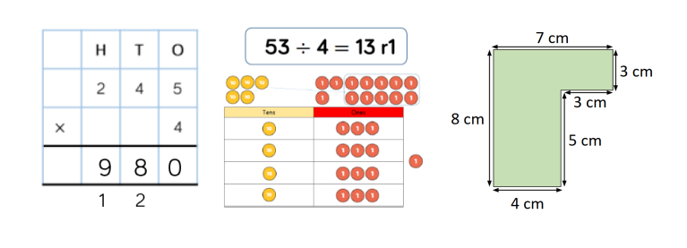
Home Time
If there are changes to the usual adult collecting your child, please inform the office or let the Year 4 team know in the morning.
If you have any questions/queries please do not hesitate to contact me via email - admin@st-stephens.tameside.sch.u or come and see me after or before school.

This term I will be updating our class web page, so please keep checking on the class pages for more resources and links that will help your child develop their love for learning.
Mrs Mistry & Miss Williams

