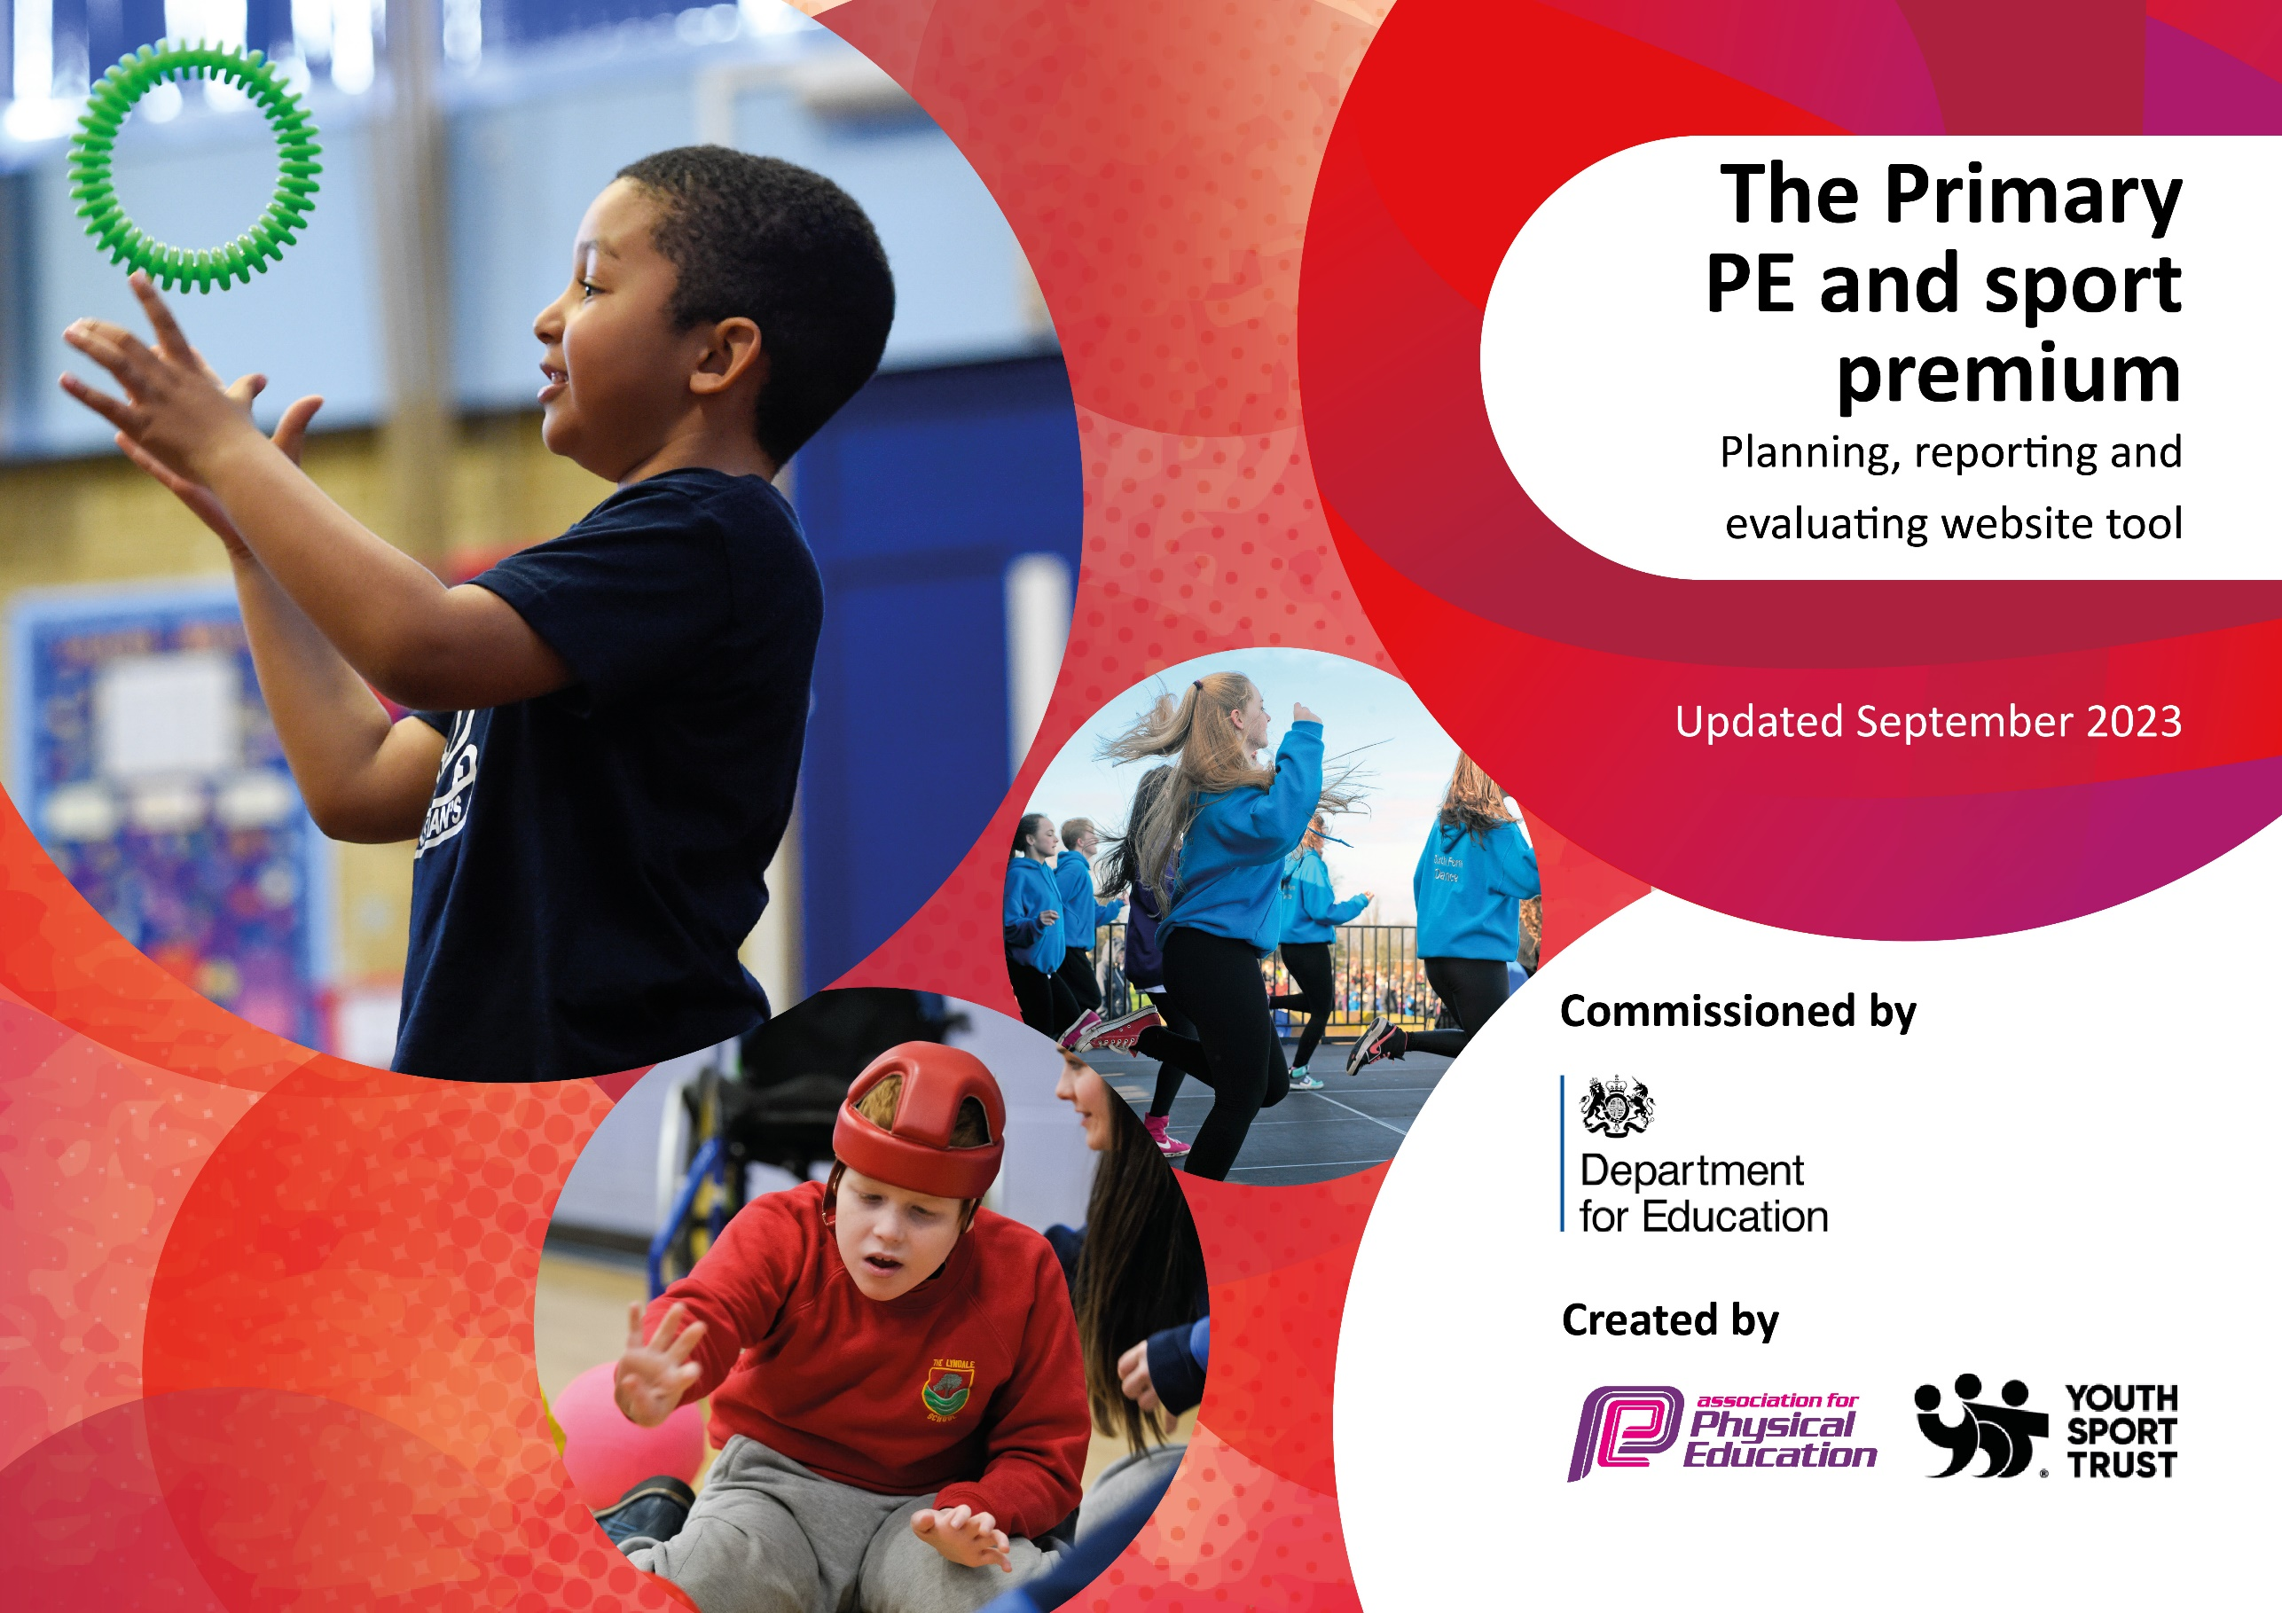

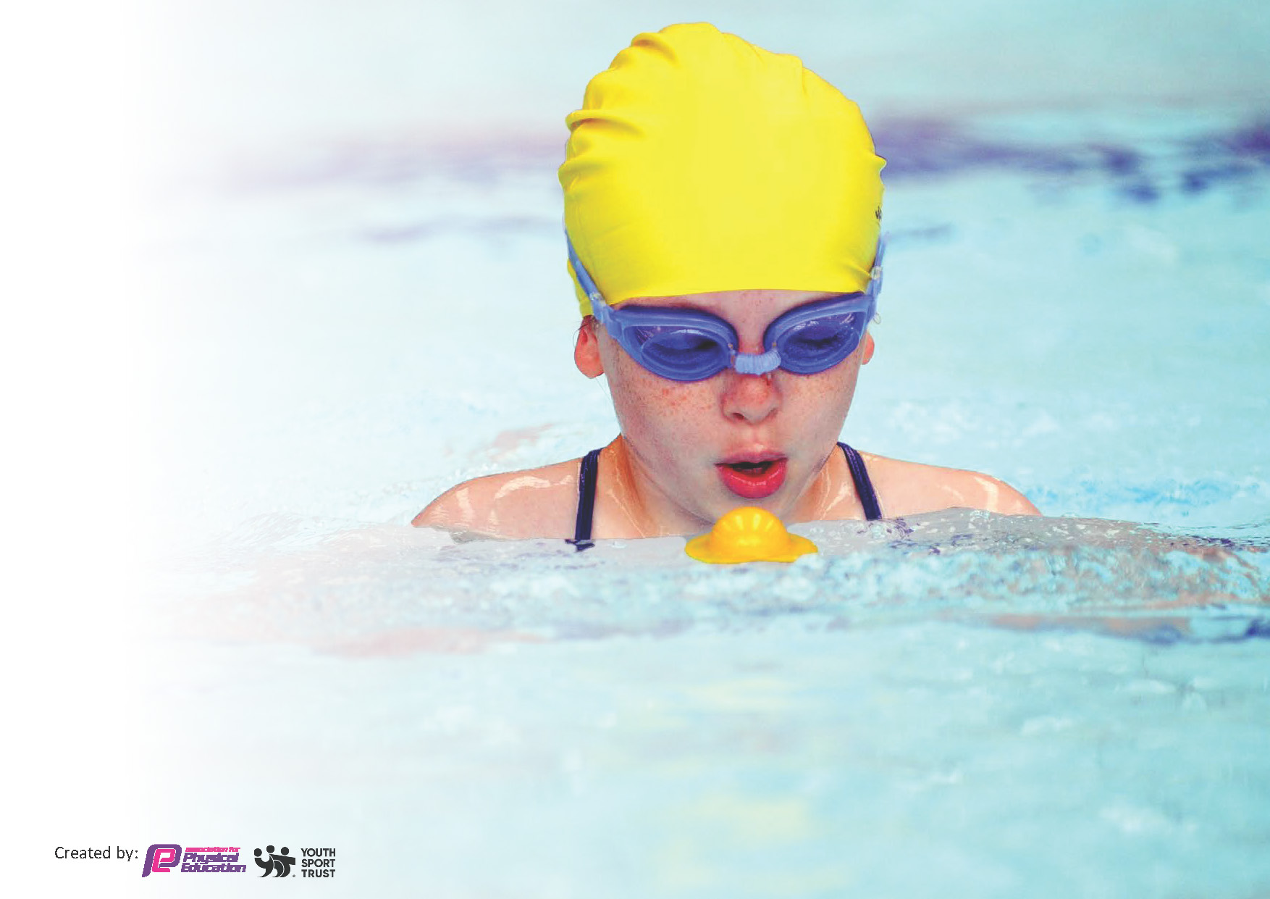
This template can be used for multiple purposes:
by:
- It enables schools to effectively plan their use of the Primary PE and sport premium
- It helps schools to meet the requirements (as set out in guidance) to publish information on their Primary PE and sport premium
- It will be an effective document to support Ofsted inspections enabling schools to evidence progress in Physical Education (PE) and evidence swimming attainment, which forms part of the PE National Curriculum. We would recommend schools consider
the Intent, Implementation and Impact of any spend, as examined within the Education Inspection Framework.

It is important that your grant is used effectively and based on school need.

Schools must use the funding to make additional and sustainable
improvements to the quality of the PE, School Sport and Physical Activity (PESSPA)
they offer. This means that you should use the Primary PE and sport premium to:

- Build capacity and capability within the school to ensure that improvements made now will benefit pupils joining the school in future years
- Develop or add to the PESSPA activities that your school already offers.

The Primary PE and sport premium should not be used to fund capital spend projects; the school’s core budget should fund these. Further detail on capital expenditure can be found in the updated Primary PE and sport premium guidance.

The Primary PE and sport premium guidance, outlines 5 key priorities that funding should be used towards. It is not

necessary that spending has to meet all the key priorities, you should select the priorities that you aim to use any funding towards.

Although completing this template is not a requirement for schools, schools are required to publish details of how they spend this funding. Schools must also outline what the impact this funding has had on pupils’ PE and sport participation and attainment and how any spending will be sustainable in the future. All funding must be spent by 31st July 2024.

The Department for Education has worked closely with the Association for Physical Education (afPE) and the Youth Sport Trust (YST) to develop this template and encourages schools to use it. This template is an effective way of meeting the reporting requirements of the Primary PE and sport premium.
Review of last year’s spend and key achievements (2022/2023)

We recommend you start by reflecting on the impact of current provision and reviewing your previous spend.

Activity/Action | Impact | Comments
Denton Community College extend class teachers session with Mr Nisbett whilst training staff for their own professional development.  Participation of PE W/class teacher  X2 1 hour of PE per week.  Invasion, striking & fielding , athletic, gymnastics and net games each term covering the full curriculum.  Lesson plans followed in guidance from PE HUB.  Assessment builder to achieve outcomes -monitored  Intra school,games – competitions w/other schools within area network.  Play leaders – x 10 childen selected to lead play/dinner time provision through games/play  Develop Dance through Active Tameside for each class years 1-6.  1 hour per class.2 classes per week (each half term)  Bikeability. Reception participates in Progression to Pedals scheme using balance bikes. | CPD- staff upskilled (Teachers and Tas in the PE HUV scheme throughout the year)  Progress from lesson 1-6. Next steps followed.  Each year group move up from July, progression to lesson applied.  Compete/ friendships, school values.  School value, teamwork, team building, friendships and communications.  Improve balance, co-ordination teamwork, friendship and confidence.  Assessments sent to each class via email and shared to Sharepoint.  Lessons taken from Bikeability through Active Tameside – 6 week course | Achieved  Achieved  Achieved  Achieved  Achieved  Achieved  Achieved

Key priorities and Planning
This planning template will allow schools to accurately plan their spending.

Action – what are you planning to do | Who does this action impact? | Key indicator to meet | Impacts and how sustainability will be achieved? | Cost linked to the action
To further raise the quality of learning and teaching in PE and school sport by providing support to deliver broad, balanced and inclusive high quality PE and school sport provision (within and beyond the curriculum) to again support us in raising pupils’ attainment.  And  To train & introduce lunchtime play time leaders throughout school  Develop expertise in teaching of Dance and for increase in high quality PE teaching participation in activity- DANCE and Tameside active. TO support deliver a broad and balanced (highly inclusive) curriculum…within and beyond the curriculum to help raise pupils attainment  Develop further curriculum and extra curriculum experiences and after school clubs- both range and frequency of clubs with ‘exit’ routes  Ie. Develop opportunities s to success community sport  Continue to develop relationships with community sport coaches across all sports and age groups  Improve physical literacy throughout the early years/KS1/KS2  Bike-ability training for Y5 again to encourage activity and develop ‘green transport’ links and facilities for chn and staff  Develop the playground markings to enable more engagement and activity at break times for all chn | TAs and pupils- child led and adult supervised sessions. Tameside Active to support PE lead to coach and direct for good quality.  Staff- Use experience and high quality resource to impact high quality teaching of PE and of Sport on every occasion in a safe and inclusive way  All children- staff have had little training and space limited at the school. Training opportunities have been scarce so supporting this (and cover) has been important  CPD opportunity for Teachers and TAs which has increased knowledge and confidence , Specialist coaching for clubs  Staff – ability to contribute positively to the area of participation and inclusion, Children – to participate and develop a love of activity and engagement in sports (also to experience a variety of sports)  Local clubs – participation to increase in local club participation  Children, staff and parents:  Linked to outreach and promotion/ links to local clubs and social media publicity  “motivation, confidence, physical competence, knowledge and understanding the value to take responsibility for engagement in physical activity for life….”  Children and staff. Children develop understanding and skills to access roads and safe cycling areas with instruction and support from expert coaches. Staff develop understanding of wider impacts of safety in activity, risk assessments and understanding of road safety  All children – engagement and use of markings during non lessons times and also for PE lessons and Games (in MUGA) for intra and inter school matches | KI 1- increase confidence , knowledge and skills of all staff  KI-2 Engagement of all pupils in regular physical activity– the Chief Medical Officer guidelines recommend that all children and young people aged 5 to 18 engage in at least 60 minutes of physical activity per day, of which 30 minutes should be in school.  KI2 engagement of all pupils in regular physical activity  KI3 profile of pe and sport is raised across the school  KI 4 broader experience of a range of sports and activities offered to pupils  (KI2 engagement of all pupils in regular physical activity  KI3 profile of pe and sport is raised across the school)  KI2 engagement of all pupils in regular physical activity  KI3 profile of pe and sport is raised across the school  KI4 Broader experience of a range of sports and activities  KI2 engagement of all pupils in regular physical activity  KI3 profile of pe and sport is raised across the school  KI 5- participation in competitive games | More pupils meeting their daily physical activity goal, more pupils encouraged to take part in PE and Sport Activities.  Sports leaders have been very good and used as role models across the school  Extra curric clubs been delivered and chn brough those skills to play /break. Positive increase in beh. at breaks, pupil activity at break and lunch increased(daily mile/ dance/ sports) , sports leaders identify passive areas/ chn and encourage and engage in structured play and activity. SMSC – chn have learnt to respect and work with others safely  Higher uptake in participation in after school clubs by Girls and PP children in this club inc. some children who previously did not attend sporting clubs. Teachers now capable of delivering dance units independently across the school. Children’s achievements have been celebrated in school and on social media  Modelling lessons and activities/ SOW has supported staff development and confidence  Progression in dance as well as assessment of dance is more accurate  To build up the post covid participation in sport and activity. Linking with local clubs and providers to enable participation to be sustainable and hold longevity. Sports day was very well attended by families. Reduction in number of chn not reaching 30 mins exercise a day, more children attending community clubs. Enhanced quality of clubs delivered.  Increased attendance at school and reduction in low level beh in lessons. Increased awareness of opportunities available in community- school signposts chn to these too.  Enabling more confidence and resilience in activity and sport, therefore increasing the likelihood of activity in a broader range of sports and activities in and out of school time.  To ensure expert teaching of road safety- a key consideration to our children with excellent cycle routes and paths available locally but within an urban conurbation  Significant uptake in activity and engagement in movement and paly since the markings have bene in place. Evidence of better play, teamwork, engagement, school/ Christian and British Values on display as well as developing resilience, teamwork, body control and movement. | £6132  £5,250  £2200  £4500  =£ 18,182  (GRANT £17,775)

Key achievements 2023-2024
This template will be completed at the end of the academic year and will showcase the key achievements schools have made with their Primary PE and sport premium spending.

Activity/Action | Impact | Comments
Playground markings in place on 3 yards and the MUGA  Active sport (Tameside) supported teacher training and quality of teaching  Dance lessons supported activities for focus children and an additional club, as well as supported teacher development in lessons  Denton Community college support- (see above)  Highly successful sports day for all classes and engagement by parents  Entry to several Tameside sports events  - 2x Ks2 classes received a term of swimming lessons and  - Bikeability (y5) | Raised engagement and physical activity levels across all year groups – ability to host practices and matches for netball , volleyball and football in MUGA  Higher quality PE teaching in evidence and relevant, up to date training for compliancy (H&S in PE)  High quality coaching for teachers for this element of the national curriculum, club and activity for all children provided, higher uptake of dance in school  Supported PE coaching and raising confidence and physical literacy in classes with higher EAL, PP ratios with the Impact of higher resilience and confidence and therefore participation in and out of school in physical activity and competitive sports IE swimming, football, rugby, dance, netball, cricket  Children performed all elements of physical literacy and values of sport as well as competed in races within cohorts to an audience for the one of the few times in several years.  Children were able to demonstrate their skills in a more challenging arena  staff development increased ability to support the teaching of skills in swimming and road safety | We will look to develop this further in the future as the outdoor environment at the school could be further maximized with the re-development of the trim trail etc too.  This will continue into 2024-5 with focus also on coaching Teaching assistants, play ground leaders and supporting our disadvantaged chn to access multi sport clubs after school  Dance lessons enabled children to participate and develop a keen interest in dance with impact on co-ordination and balance which transferred in to other lessons/ sports. Dance was also incorporated into a club, dancing outside schooltime and school productions.  Increased quality of lesson support and engagement for the children in these classes with high quality and trained staff. This support enabled a higher proportion of PP children to participate in school sports fixtures too.  Children developed a thirst for competition as well as participation- areas still not revived since covid -19 pandemic. Engagement led to new areas to look into in 2024-5 for use of facilities, links with clubs and how to develop skill based teaching as well as games based performances.

Swimming Data
Meeting National Curriculum requirements for swimming and water safety.
Priority should always be given to ensuring that pupils can perform safe self-rescue even if they do not fully meet the first two requirements of the National Curriculum programme of study

Question | Stats: | Further context  Relative to local challenges
What percentage of your current Year 6 cohort can swim competently, confidently and proficiently over a distance of at least 25 metres? | 80% (24/50) | We are struggling to get pool space due to our local pool timetable and rising cost of the provision.  Covid impacted this cohort at t developmental stage with the closing of pools .  We have had to limit the number of pupils attending swimming lessons during one term which means some pupils have attended fewer swimming lessons than others.
What percentage of your current Year 6 cohort can use a range of strokes effectively [for example, front crawl, backstroke, and breaststroke]? | 83% (25/30)

What percentage of your current Year 6 cohort are able to perform safe self-rescue in different water-based situations? | 83% (25/30) | .
If your schools swimming data is below national expectation, you can choose to use the Primary PE and sport premium to provide additional top-up sessions for those pupils that did not meet National Curriculum  requirements after the completion of core lessons. Have you done this? | Yes/No | Option not available but this will be used in 2024-5 subject to availability for Y6 children
Have you provided CPD to improve the knowledge and confidence of staff to be able to teach swimming and water safety? | Yes/No | Staff with little past knowledge of swimming teaching have been encouraged to learn and join in coaching whilst shadowing the lead instructors. Several teachers were enabled to do this over the 2 full terms of the swimming across 2 classes at school. This has been done with professional qualified swimming teachers at a local pool

Signed off by:

Head Teacher: | G Lovgreen
Subject Leader or the individual responsible for the Primary PE and sport premium: | Oliver Lindsay , G Lovgreen
Governor: | (Name and Role)
Date: | 29/7/24

