**

**Year 1 Curriculum Overview**

Autumn 1 2025

**P.E.**

PE will be taught on a Monday practising travelling with equipment and a Wednesday where we will look at some gymnastics.

**SCIENCE**This half term we will be focussing on exploring everyday materials with understanding what things are made of, looking at lots of materials e.g. metal, plastic, wood and glass and what physical properties the materials hold and comparing them to each other.

**ENGLISH**

This half term, our ‘book for hook’ is ‘Supertato’. We will use the structure of the story to write some instructions with simple directions and test to see if we can all follow them.

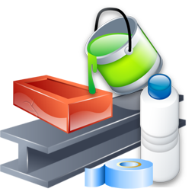

**HISTORY**

In History, we are exploring at how we learnt to fly with looking at events beyond living memory with core concepts focusing on transport and technology and knowing the significance of the Wright Brothers.

**MATHS**In Maths this half term we will be focussing on place value and addition and subtraction where we will sort objects, more than and less than, number bonds to 10, part-whole models and number sentences.

**MUSIC**

We will be learning about rhythm and music notation.

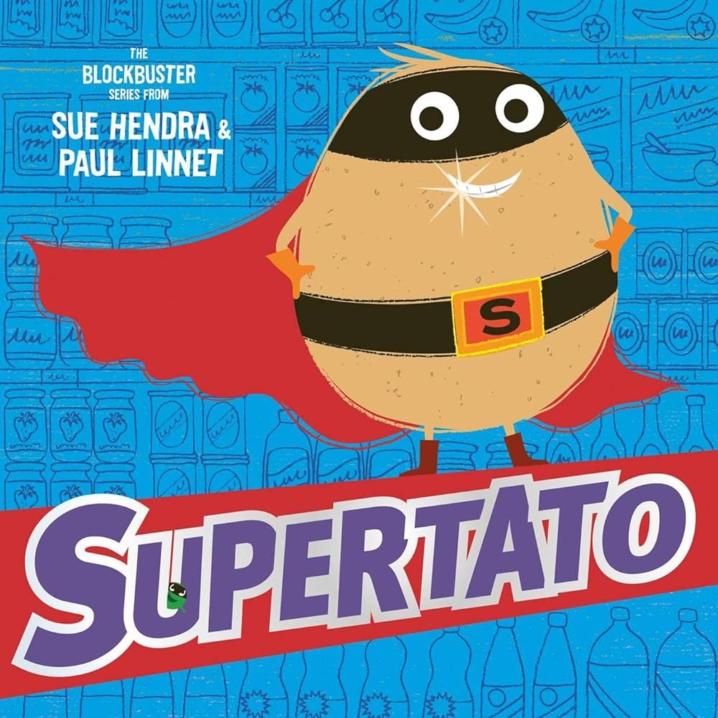z

**PSHE**In PSHE this term, we will be looking at ‘Being Me in My World’ with the rights and responsibilities but also where we can feel special and safe in our world.

**MUSIC:**

In music, we will be learning to sing and perform ‘Hey You!’ by Joanna Mangona and be able to compose our own songs.

**ART:**

In Art, we will be exploring drawing and making your mark with experimenting with lines and waves.

**R.E.**In RE, we will be looking into and discussing ‘Who do Christians say made the world?’ linking to Creation.