**

**Year 1 Curriculum Overview**

Autumn 2 2025

**P.E.**

PE will be taught on a Monday practising throwing and catching and a Wednesday where we will start our Gymnastic unit.

**SCIENCE**This half term we will looking into seasoning changes within Autumn and Winter with identifying all four seasons, and finding out the signs of all seasons and knowing when each season is about to start. This will be done by gathering and recording observations.

**ENGLISH**

This half term, our ‘book for hook’ will be ‘Lost and Found’. Using this story, we will recounting the key events while making a narrative about an unfamiliar setting.

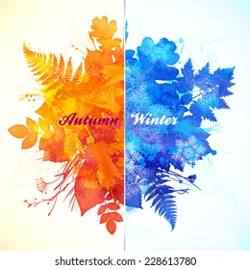

**GEOGRAPHY:**

In Geography this half term we will be exploring what it is like where we live in the UK, looking at the core concept of Scale and Place. We will look at the differences between a map, a plan and an aerial photo using our observational skills.

**MATHS**In Maths this half term we will be focussing on fact families in addition and subtraction using number lines and sorting 2D and 3D shapes with recognising names and patterns of each shape.

**MUSIC**

We will be learning about rhythm and music notation.

**DT:**

In DT, we will be exploring cooking and nutrition with making a final project of smoothies.

**MUSIC:**

In music, we will be learning to sing and perform Rhythm in the way we walk with the Banana Rap using actions.

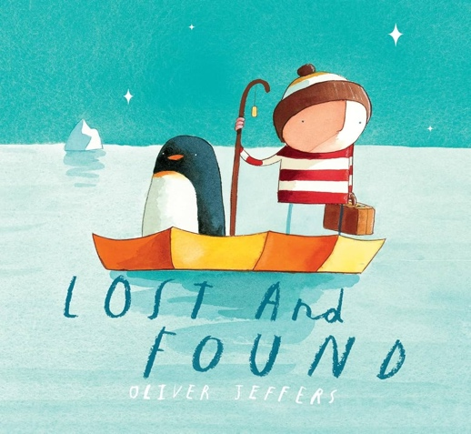

**R.E.**In RE, we will be looking into and discussing ‘Why does Christmas matter to Christians?’ linking to Incarnation.

**PSHE**In PSHE this term, we will be looking at ‘Celebrating Differences’ with what is Bullying and who we can talk to about this and how we can make new friends.