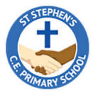


Year 5 Curriculum Overview
Spring 1 - 2026

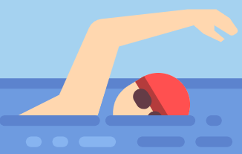
ENGLISH - This half term in English we will be reading Jumanji and focusing our writing on producing a narrative in an unfamiliar setting. We will then move on to produce a non-chronological report.

P.E & SWIMMING - This half term, the children will be having a PE lesson on a Monday afternoon and a swimming lesson on Friday afternoon. During the Spring term, Year 5 will be attending swimming lessons. Children should come to school in their full school uniform and bring their swimming kits with them. Appropriate swimwear must be worn to each swimming lesson. Swimwear should be a one-piece swimming costume for girls and swimming trunks for boys. The children are allowed to wear swimming shorts that are lined and are not below mid-thigh in length and which will not hamper swimming development. More information is available on our class page under the Swimming PowerPoint.

FRENCH - In French, we will be learning all about food, recalling a variety of foods in French and exploring what we like and dislike and how to place an order. We will also look at time and how to tell the time in French.
MATHS - In Maths, we will begin the term with multiplication and division, looking at the long multiplication method and recapping short division with larger numbers. The children will then move back on to fractions, where they will find fractions of an amount, finding the whole, multiplying fractions and using fractions as operators.

R.E - In RE, we will be exploring the question ‘How do Christians live?’ and delving deeper into Christianity.
HISTORY - This half term in History we will be exploring if life was better when the Anglo-Saxons came. We will learn about their legacy and how they lived. We will be able to order periods of history on a timeline, evaluate evidence, make comparisons to features of past history, know and explain how significant events have shaped the country we have today.

PSHE - In PSHE, we will be exploring our ‘Dreams & Goals’ in life and how they play an important part in our learning journey.

ART - In Art this term, we will be exploring portraits and how different portraits can share different messages. We will have a go at continuous line drawing, explore a variety of artists and create our own version of a portrait.
MUSIC - In Music, we will be learning how to produce, compose and evaluate a ‘spooky’ tracking using YuStudio. We will be exploring different melodies, beats and chords to create a completed track with our peers.
SCIENCE - This half term in Science our unit is Earth and Space. In this unit, we will explore the planets in our solar system, explain how planets move, explore the difference between night and day and look closely at the movement of the moon.
MUSIC
We will be learning about rhythm and music notation.

