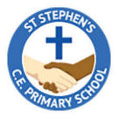


Year 1 Curriculum Overview
Spring 1 2026

SCIENCE
This half term we will be exploring animals including humans with looking at our five senses with parts of the body it relates to. We will be identifying the names of common animals including fish, amphibians, reptiles by sorting them into herbivores, carnivore and omnivores.
P.E.
PE will be taught on a Monday practising some Gymnastics and Dance skills and a Wednesday where we will start with hit, catching and running.

ENGLISH
Our ‘book for hook’ this half term is ‘Betty and the Yeti’. We will use the structure of this story to write up a narrative and a non-chronological report.

HISTORY
In History, we will exploring our local area with pictures from the past about who taught us how to aspire with significant individuals in the past who have contributed to national and international achievements.

MATHS
In Maths this half term we will be focussing on more place value with number to 20 and 50 and length and height, measuring shapes and objects in the classroom using centimetres.

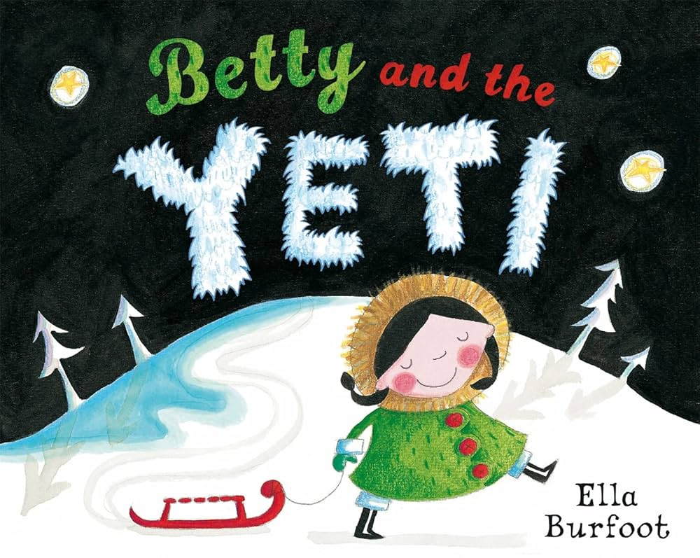
MUSIC
We will be learning about rhythm and music notation.

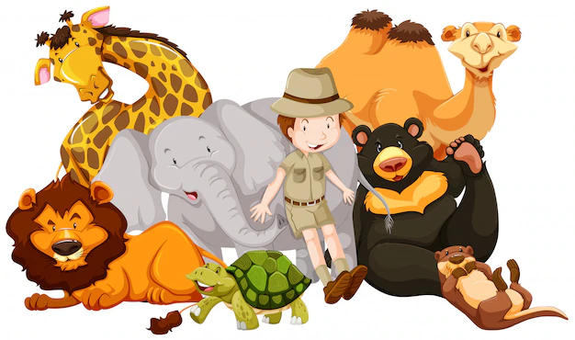
R.E.
In RE, we will be looking into and discussing ‘Who is Muslim and how do they live day to day?’.

PSHE
In PSHE this term, we will be looking at ‘Dreams & Goals’ and how we can achieve great things together by overcoming obstacles.

ART:
In Art, this half term we will be exploring colour splashes with painting and mixed media.
MUSIC:
In music, we will be learning to sing and perform ‘In the Groove’ using our vocals and the glockenspiels.

