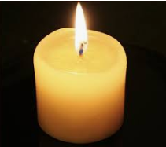

Collective Worship

St Stephen’s CE

Primary School

Dismissal - Call and response

**Leader: May God bless you in all you do and say today.**

**Response: Amen**

Worship song or hymn

Welcome - Call and response

**Leader: Jesus the light of the world is here.**

**Response: Lord Jesus shine upon us.**

Light a candle

**Take time to be quiet and allow everyone to prepare for collective worship. Use music to create the right mood for worship.**

Worship talk

**Beginning with the bible, give time to discuss and reflect on the worship focus. Include children and adult’s thoughts and ideas and prayers.**

School Prayer – Led by a child

**O Lord, Bless our school**

**That by working together**

**And praying together,**

**We may learn to serve you**

**And to serve one another,**

**Through Jesus Christ our Lord**

**Amen.**