

|  |
| --- |
|  |

Collective Worship Policy

November 2023

At St Stephen’s CE Primary School, our Christian values run through our school like a golden thread and enable our children to flourish and ASPIRE in life. Our Christian vision: ‘*for with God, nothing is impossible’ (* Luke 1 : 37), helps support and guide our whole school community in striving to beat our previous best endeavours.

Throughout the year, we re-focus on a Christian Value in order to keep God in the centre of our lives. By linking these to key events within the Christian calendar our children will all take turns in leading key collective worships for our whole school community at St Stephen’s Church, once a year.

|  |  |  |  |  |  |
| --- | --- | --- | --- | --- | --- |
| Autumn 1 | Autumn 2 | Spring 1 | Spring 2 | Summer 1 | Summer 2 |
| Thankfulness | Respect | Hope | Forgiveness | Love | Trust |

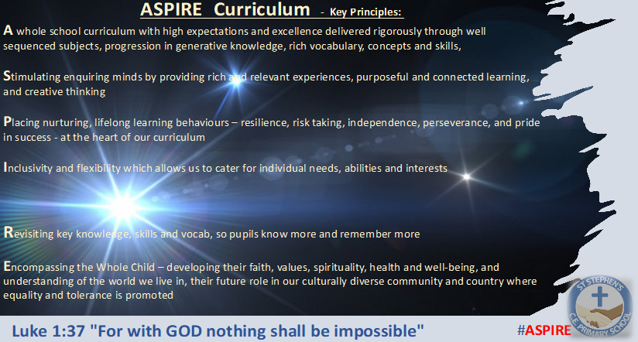

The key principles of our ASPIRE vision support our decision-making process at St Stephen’s CE Primary School for the curriculum. With these principles in place, our children are able to know more and remember more across development of our broad and balanced curriculum.

**St.Stephen’s Church of England Primary School**

**Collective Worship Policy**

**We believe that Collective Worship plays a very important role in the life of our school here at St Stephen’s Ce Primary School. It is an opportunity to promote the Christian foundation of our school, to celebrate and support all aspects of school life and to provide time for stillness and reflection in what is often a very busy, active day for our children. We recognise that in our school at present we have children from mainly Christian faith traditions and those who have different or no-faith background. Great care and sensitivity will be taken to ensure that all our children feel valued and special. Collective Worship will be known can also be known as ‘Worship Time’ in our school.**

**In Autumn 2023, we look to revisit and redevelop our Chrisitan aims and Christian values to enable them to be refreshed and relevant to the school as it now was …and where we were heading. The values were chosen with SLT, Staff, Governors, Clergy and consultation with the diocese education advisors. Using the ‘Called Connected, committed’ document (and podcasts) members of the leadership spoke with Andy Wolfe and with this inspiration were committed to ensuring that as a Christian School we**

**ASPIRE……. “for with God, nothing shall be impossible” (Luke 1:37)**

**This process will see us develop the philosophy through the curriculum and Christian distinctiveness of our school over the coming years and be the golden thread which links all we do, together.**

**All our new documentation and policies display this aim, as we use it to hold ourselves to account to the principles and vision it gives us as adults, as educationalists and as leaders to strive continually to give more to our children at St Stephen’s CE.**

**The key principles we shall measure ourselves against and set our guidance by were set out as:**

**Aims**

**The main aims of collective worship and worship times are:**

**• To provide opportunities for pupils to worship God.**

**• To promote pupil’s spiritual, moral, social and cultural development.**

**• To enable pupils to explore their own beliefs.**

**• To come together and promote a common sense of ethos and shared values.**

**• To help our pupils to develop respect for and sensitivity to the beliefs, culture and values of others.**

**• To explore Christianity whilst fostering a respect for peoples of all races and faiths.**

**• To help our pupils understand the nature and language of worship.**

**• To support the broader curriculum through the use of art, music, dance, poetry, story, drama and other visual and oral means of communication.**

**The 1988 Education Reform Act states that collective worship must be on a daily basis for all registered pupils. The religious foundation of St. Stephen’s School as stated in the Trust Deed is Church of England and the daily Act of Collective Worship is delivered in accordance with the principles and practice of the Church of England. Parents have the right to withdraw their children from the Daily Act of Worship. A parent wishing to do so will need to make a written request to the Headteacher.**

**Organisation**

|  |  |  |  |  |  |
| --- | --- | --- | --- | --- | --- |
| Autumn 1 | Autumn 2 | Spring 1 | Spring 2 | Summer 1 | Summer 2 |
| Thankfulness | Respect | Hope | Forgiveness | Love | Trust |

**In order to promote our pupil’s learning and meet the needs of different age groups, our Worship Times vary in size and groupings. Our current schedule is as follows:**

**• Monday – Class led collective worship led by the class or teacher**

**• Tuesday- Collective worship in the hall led by the Headteacher or Vicar. A class will take it in turn to write a prayer themselves and read it to the school (then add it to the newsletter that week)**

**• Wednesday- Class led collective worship with a theme of worship through music**

**• Thursday- Class collective worship with a theme on or question set for the class by the SLT.**

**• Friday-Celebration Assembly (which includes informing the school of Housepoint totals for the week and awarding of class Christian Values in action, and Star of the week, then finally the Attendance awards)**

**These will be led by either the Headteacher, Deputy Headteacher or SLT and from Sept 2023 we will hold these in person and invite parents to celebrate with us if their children have won an award!**

**\*\*Classes are encouraged to lead Collective worship for other classes during their class collective worship times within the theme of that half term.**

**Each Collective worship will follow a uniform order to ensure key aspects are covered and enjoyed by the children . These have been shared with parents, governors and clergy. This Collective Worship Order includes the important symbolism of welcoming Jesus, the light of the world into our lives.**

**Each part is supplemented with foci form the Bible and most importantly…living our school values as we go about our lives in the school and our community.**

**Act of Worship Framework**

**• Worship themes are planned half-termly and reflect the Christian church year.**

**• They promote the Christian values of our school Ethos.**

**• They are usually linked with curriculum themes or special occasions and festivals through which these key issues can be developed.**

**Each class will take a collective worship in church each year to our wider school community (usually on the morning of the last Thursday of each half term). This means that all our children have an ASPIRE moment and can be celebrated in our most sacred building.**

**• Reference to festivals and main events in other main world religions such as Judaism, Islam, Hinduism and Sikhism may be made with the intention of promoting understanding of others who hold differing beliefs to ourselves. We do this with the aim of developing Community Cohesion in our modern and multi-cultural world.**

**The key issues relate to our Mission Statement and include love, respect, honesty, caring and sharing, change, trust, fairness, the wonders of nature and the gospel values. The record of Worship Time have been logged in the Assembly folder where activities and resources can be logged. Related bible readings, prayers, music and hymns are also recorded on the grid. This grid aims to help staff plan Acts of Worship and to avoid unnecessary repetition. Although the themes will be revisited on an annual basis, they are broad enough to allow for sufficient choice and flexibility. Worship Times should last approximately 15-20 minutes.**

**Prayer and reflection times are used throughout the week but are particularly pertinent before lunchtime and before the children leave each day.**

**A school prayer was written and led for the school for cohesion and to start a journey together to build on our Christian Distinctiveness. This will develop more themes like prayer areas and reflection areas around school in the following years.**

**Elements of Worship**

**• Songs and music from a variety of cultures (if appropriate.)**

**• Prayer (both traditional, contempory and simultaneous)**

**• Reflection and contemplation.**

**• Individual and group activity.**

**• Readings, sermons.**

**• Artefacts.**

**• Discussion, speech, sharing thoughts and feeling (and good deeds!) and silence.**

**• Dance and drama.**

**• Use of the senses.**

**• Artistic imagery.**

**• Different seating plans**

**Attitudes to be developed.**

**• Sense of beauty, awe and wonder.**

**• Feelings of belonging.**

**• Respect for others regardless of gender, social, racial or cultural differences.**

**• Sense of pride.**

**• Sense of pity, empathy.**

**• Sense of peace or thankfulness.**

**• Sense of shared sadness or loss.**

**• Sense of smallness in the face of the greatest of things.**

**• Sense of grandness in the face of the smallest of things.**

**• Sense of stillness in the midst of a busy experience.**

**Record Keeping, Evaluation and Monitoring**

**Any comments should be brief and aid the planning of future Worship Times.**

**Children will evaluate the Act of Worship each day through discussions within their classes which serve to reinforce the themes.**

**The collective worship leader (s) is responsible for monitoring the Collective Worship. This process will involve all staff. It shall be carried out as part of the whole school self review process.**

**Resources- Each class will have an area in their classroom that is a focus for their class Acts of Worship. This spiritual corner will contain a focal point chosen by the class such as a Christian symbol (e.g. cross or poster) and a candle reflecting the time in the Church’s year. Each class should have a bible and a collection of prayers to use. Other bibles, bible stories and prayer books are kept in the library. Most Christian artefacts are displayed around school and are available for use at any time. All hymn music is kept online. Teacher resource books / folders with ideas for Collective Worship are kept by staff in their historic folders / planning**