**Year 1 Autumn 2 Relationships**

**Who is special to us?**

**Previous Learning from the EYFS Curriculum**

**Area of Learning: Understanding The World**

**Aspect: People Communities and Cultures**

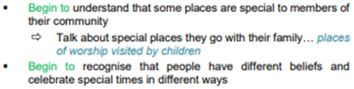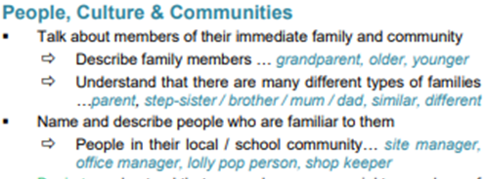

**Vocabulary**

* Ourselves and others
* people who care for us
* groups we belong to
* families

**Key Knowledge for unit**

**Children will learn:**

* that family is one of the groups they belong to, as well as, for example, school, friends, clubs
* about the different people in their family / those that love and care for them
* what their family members, or people that are special to them,
* do to make them feel loved and cared for
* how families are all different but share common features – what is the same and different about them
* about different features of family life, including what families do / enjoy together
* that it is important to tell someone (such as their teacher) if something about their family makes them feel unhappy or worried