**Year 2 Relationships**

**What makes a good friend?**

**Previous Learning from the EYFS Curriculum**

**Area of Learning: Personal Social and Emotional Development**

**Aspects: Self Re**

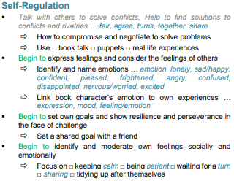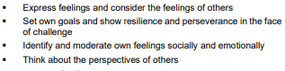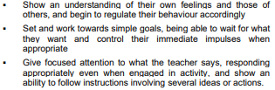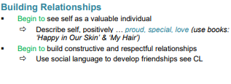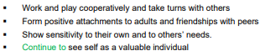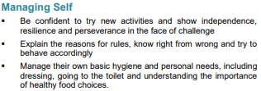

**Key Knowledge for unit**

**Children will learn:**

* that people have different roles in the community to help them (and others) keep safe - the jobs they do and how they help people
* who can help them in different places and situations; how to attract someone’s attention or ask for help; what to say
* how to respond safely to adults they don’t know
* what to do if they feel unsafe or worried for themselves or others; and the importance of keeping on asking for support until they are heard
* how to get help if there is an accident and someone is hurt,
* including how to dial 999 in an emergency and what to say

**Vocabulary**

* Keeping safe
* people who help us