**Year 2 Summer 2 How do we recognise our feelings?**

**Previous Learning:**

**Previous Learning from the EYFS Curriculum**

**Area of Learning: Personal Social and Emotional Development**

**Aspect: Self Regulation**

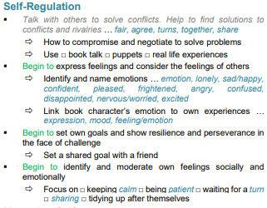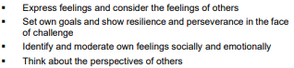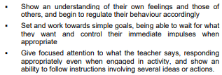

**Vocabulary**

* Feelings;
* mood
* times of change;
* loss and bereavement;
* growing up

**Key Knowledge for unit**

**Children will learn:**

* how to recognise, name and describe a range of feelings
* what helps them to feel good, or better if not feeling good
* how different things / times / experiences can bring about different feelings for different people (including loss, change and bereavement or moving on to a new class/year group)
* how feelings can affect people in their bodies and their

behaviour

* ways to manage big feelings and the importance of sharing their feelings with someone they trust
* how to recognise when they might need help with feelings and how to ask for help when they need it