Year 3 Spring 2 Living in the Wider World
What makes a community?
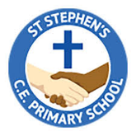

Previous Learning:

Y2 Spring 2 What Jobs do people do?
- that people have different roles in the community to help them (and others) keep safe - the jobs they do and how they help people
Yr1 Summer 1 Who helps to keep us safe?
• that people have different roles in the community to help them (and others) keep safe - the jobs they do and how they help people

Vocabulary

- Community;
- belonging to groups;
- similarities and differences;
- respect for others

Key Knowledge for unit
Children will learn:
- how they belong to different groups and communities, e.g. friendship, faith, clubs, classes/year groups
- what is meant by a diverse community;
- how different groups make up the wider/local community around the school
- how the community helps everyone to feel included and values
the different contributions that people make
- how to be respectful towards people who may live differently to them

